2024 SEACOAST NORWAY & COPENHAGEN TRIP
August 28, 2024 – September 7, 2024

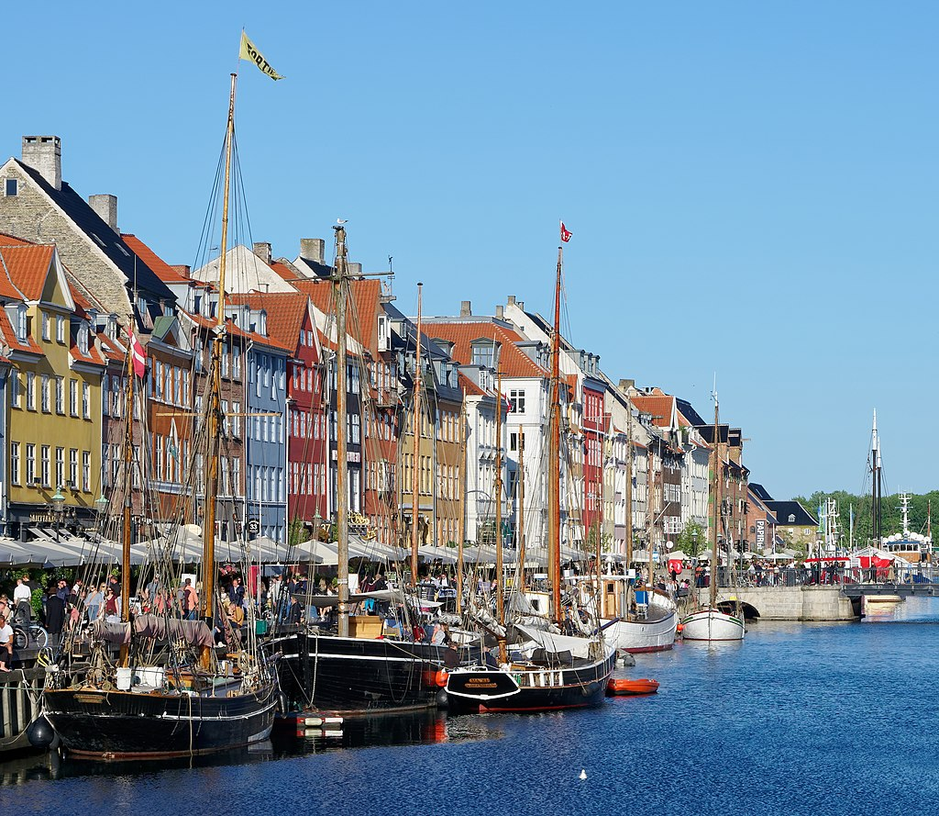
Day 1: To Copenhagen
Leave Boston for your flight to Copenhagen

Day 2: In Copenhagen (B,D)
After arriving in Denmark’s vibrant capital city, we’ll do an orientation walk of central Copenhagen.

This evening we’ll have a welcome dinner in Tivoli Gardens. Opened in 1843, Tivoli with its extensive pleasure gardens is the second-most popular seasonal amusement park in the world.

Day 3: In Copenhagen (B)
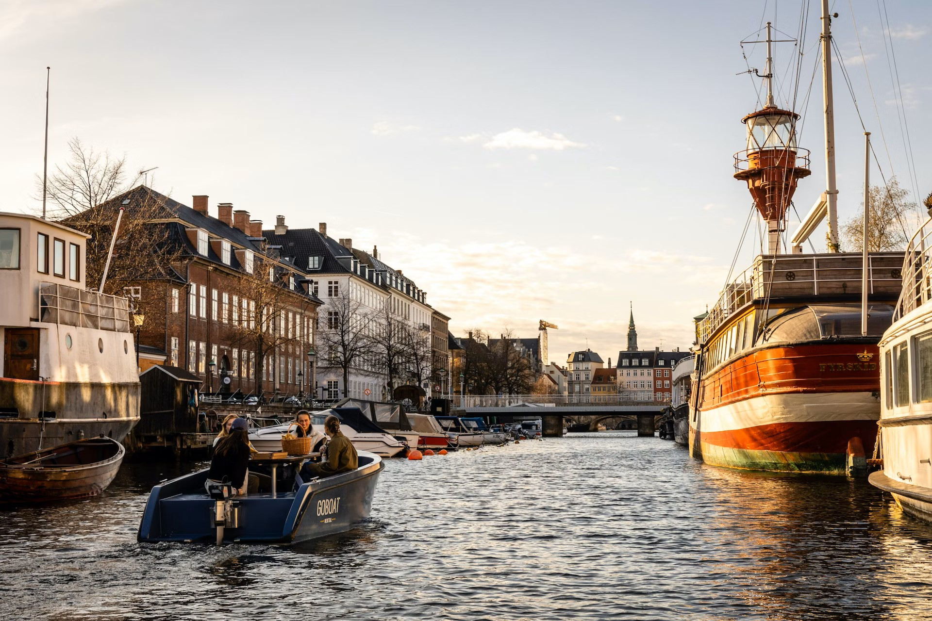
This morning we’ll walk to the port and form our own flotilla of electric boats for a tour of Copenhagen’s canals. You can buy some sandwiches and drinks beforehand for a floating picnic.

You’ll have the afternoon free to visit some of Copenhagen’s many fine museums, such as the Gylptotek with it’s French and Danish art or the National Museum with it’s Viking collection. The Rosenborg Castle with the Danish crown jewels is also a good option. Copenhagen is a very walkable city, but you can also rent a bicycle if you wish

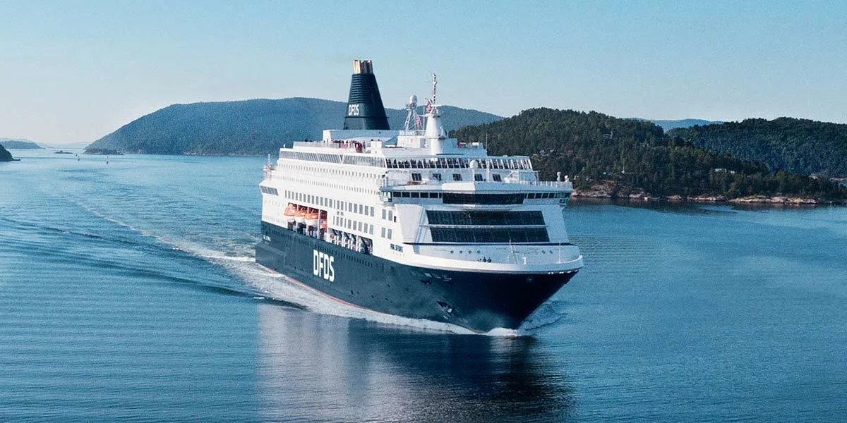
Day 4: Overnight cruise to Oslo (B,D)
The morning is free for shopping or sight seeing.

We leave in the afternoon to catch our overnight ship to Oslo. We’ll sail the sound between Denmark and Sweden before having a buffet dinner.

Day 5: Drive to Flåm (B,D)
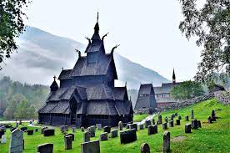
In the morning we’ll sail into the narrow Oslo fjord. Upon arrival in Oslo, we’ll join our coach and head to the Borgund Stave Church, dating from 1180, for an inside tour. Then we continue 15 miles through the world’s longest road tunnel to Lærdal with its 161 protected wooden buildings and on to the fjord village of Flåm, where we’ll spend the next two nights. Next to our hotel is the Viking inspired Ægir Brewery, which is considered to be one of the best micro-breweries in Norway.

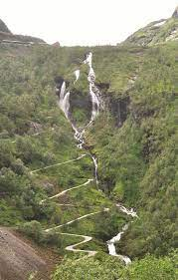
Day 6: Day in Flåm (B, L, D)
Today’s excursion starts with the famous Flåm railway with a train ride up the valley, ascending 2,900 feet in less than an hour. Then we’ll bike back down to Flåm through 14 miles of stupendous scenery. A picnic lunch will be had en route. Those who prefer not to do the bike ride down will have the option of taking the railway down instead. We arrive back in Flåm in the early afternoon. A late afternoon RIB boat or Kayak excursion can be arranged or we can rendezvous at the Ægir Brewery for a well-earned adult beverage.

Day 7: Flåm to Ullensvang (B,D)
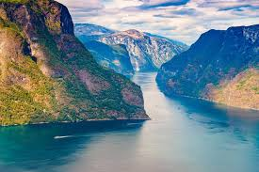
We start this morning with a two-hour fjord cruise starting on the Aurlands Fjord and then on to Norway’s narrowest fjord, the Nærøy Fjord, which is on UNESCO’s World Heritage list. We will then do a short walk on the Stalheim Mountain road and travel across the Hardanger Fjord on Norway’s longest suspension bridge. Weather permitting, we’ll give the option of walking over the 1.3 kilometer long bridge.

Late afternoon arrival to the fjord hamlet of Lofthus. You’ll spend two nights here at the Hotel Ullensvang, enjoying traditional Norwegian buffets for dinner.

Day 8: Ullensvang, (B,D)
Free day for hiking or relaxing at the hotel. We’ll offer a moderate group hike through the fruit orchards, but the more ambitious can do a rigorous hike from the fjord to the top of the surrounding mountains that tower 3,000 feet above the village.
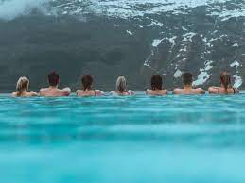
Hotel Ullensvang has two indoor/outdoor pools, sauna and spa. Boats can be borrowed for rowing on the fjord. The adventurous can even take a swim in the fjord.
This hotel has been rated the #1 Hotel in Norway AND boasts the #1 Hotel Pool in Norway AND is a favorite of the Norwegian Royal family!

Day 9: Ullensvang to Oslo, (B)
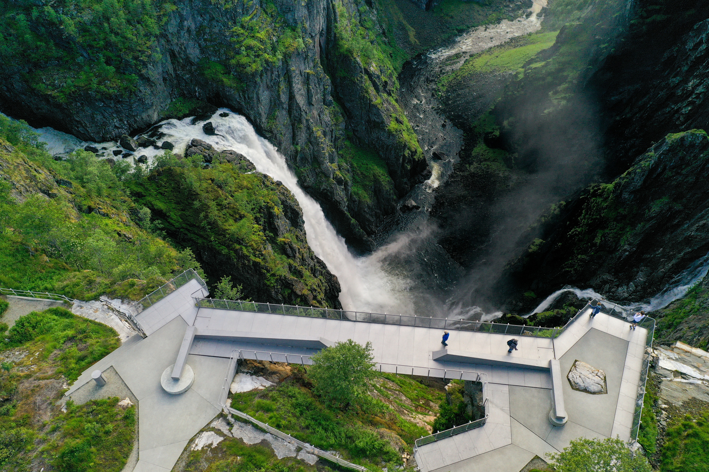
This morning we leave Ullensvang and head above the tree line to the Hardangervidda Mountain Plateau, home of thousands of reindeer. We’ll stop at the top of the Vøringsfossen waterfall, for a breathtaking view. Brave souls can walk across the footbridge spanning a deep ravine – the rest can take the bus to the other side.

After checking in to our hotel, we’ll do an orientation walk of central Oslo ending with a walk up the marble clad, sloping roof of the Oslo Opera House.

After the tour there are many nearby dining options for dinner on your own.

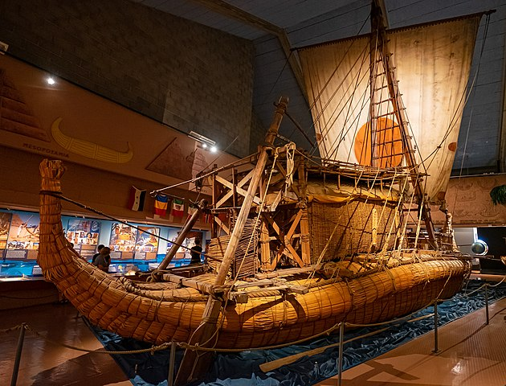
Day 10: In Oslo, (B, D)
This morning you’ll receive an Oslo Pass which will give you free admission to all of Oslo’s museums and public transportation. We’ll start the day together with an inside tour of the impressive Oslo City Hall where the Nobel Peace Prize is awarded each year on December 10.

Afterwards, we’ll take the ferry to Bygdøy to the Fram Museum to see the ship that Roald Amundsen used when he was the first man to the south Pole. We continue with a visit to the Kon-Tiki Museum.

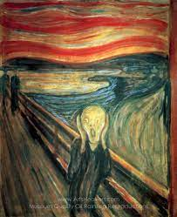
After visiting these museums, you'll return by ferry to Oslo and visit museums of your choice at leisure. Within a short distance of where the ferry docks, you’ll find the Resistance Museum that chronicles Norwegian resistance during WW II, the Nobel Peace Prize Center and the National Museum with Edvard Munch’s “The Scream” and many other paintings of note. In the early evening we’ll meet up again for a tour of the Vigeland Sculpture Park. We will travel to the park by the Metro and return by tram to the harbor.

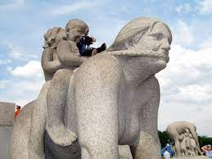
This evening we’ll have our farewell dinner

Day 11: Oslo-Flight home (B)
Morning transfer to airport

Price includes:
- Round trip flights from Boston
- Experienced English speaking guide throughout.
- 9 nights’ accommodation.
    - All hotels with private facilities
    - First class centrally located hotels in Oslo and Copenhagen
    - Scenic view rooms at the Ullensvang Hotel
- Daily buffet breakfast plus 7 dinners and one lunch
- Welcome dinner in Tivoli Gardens
- All entrances and activities in itinerary, 24-hour Oslo Pass and transportation with group.
- Private coach

Highlights:
- Welcome dinner at Tivoli Gardens
- Electric boat tour of Copenhagen’s canals
- Overnight cruise from Copenhagen to Oslo
- Boat trip on the Fjords
- Flåm railway up to Myrdal and bike ride down the Flåm Valley
- Visit to Borgund Stave Church
- Free day for hiking or relaxing by the Fjord at the Ullensvang hotel.
- Fram Museum, Vigeland Sculpture Park and other sights in Oslo with the Oslo Pass

