Athens and the Greek Isles
May 20-30, 2023

Day 01 May 20: Depart the US fly BOS-ATH
Day 02 May 21:
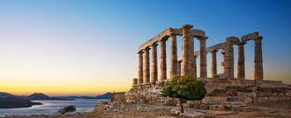
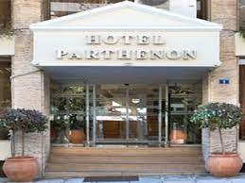
- Arrival in Athens, Greece
- Stay two nights at the Hotel Parthenon (or similar) https://www.airotel.gr/en/
- In the afternoon, an excursion to the Temple of Poseidon in Cape Sounion, a little over an hour’s drive from Athens, along a scenic route by the sea.
- Dinner included in Kalyvia on the way back from excursion
- Overnight in Athens
Day 03 May 22:
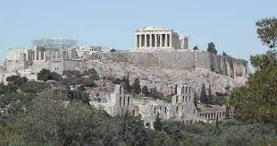
- Panoramic tour of the Historical Center of Athens – sightseeing and three-mile walk around the sites and hills of Athens, including a Guided Tour of the Acropolis and ancient Agora
- Dinner on our own
- Overnight in Athens

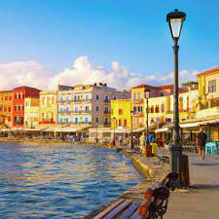
Day 04 May 23:
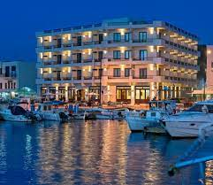
- Morning flight to Chania, Crete
- Stay two nights at the Hotel Porto Veneziano (or similar) https://portoveneziano.gr/
- Midday guided walking Tour of the city
- In the late afternoon, a visit to Manousakis Winery for wine tasting
- Dinner included after wine tasting
- Overnight in Chania, Crete
Day 05 May 24:
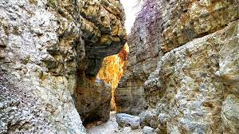
- Hiking at the Imbros Gorge, combined with Sfakia for swimming & lunch (included),
- Dinner on our own
- Overnight in Chania, Crete

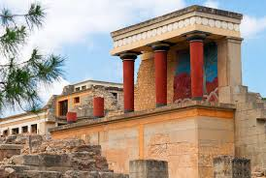
Day 06 May 25:
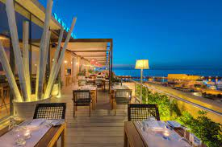
- Move from Chania to Heraklion, the capital city of the island of Crete. The drive is about 2 hours
- Stay one night at the Hotel Megaron(or similar) https://www.gdmmegaron.com/
- Tour of the Minoan Palace of Knossos and the Archeological Museum in Heraklion
- Dinner included in Heraklion
- Overnight in Heraklion, Crete
Day 07 May 26:
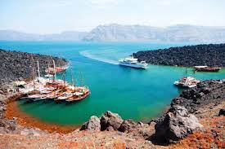
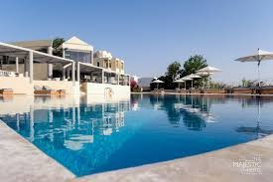-
- Morning Ferry to Santorini
- Stay one night at the Hotel Majestic(or similar) https://www.hotel-majestic.gr/
- Volcano & Hot springs cruise,
- Dinner included in Santorini
- Overnight in Santorini

Day 08 May 27:
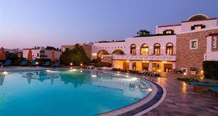
- Ferry from Santorini to Paros/Naxos
- Stay two nights at the Hotel Porto Naxos(or similar) https://www.portonaxos.gr/
- Grecian culinary event (local)
- Dinner included with culinary event
- Overnight in Paros/Naxos
Day 09 May 28:
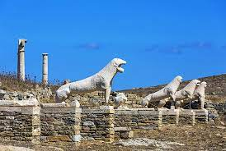
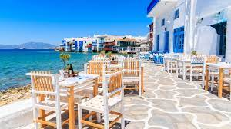
- Ferry to/from Mykonos for the day
- Sail across the harbor to ancient ruins on Delos from Mykonos
- Dinner on our own
- Overnight in Paros/Naxos
Day 10 May 29:
- Morning Ferry from Paros/Naxos to Athens
- Return to the Hotel Parthenon (or similar)
Day 11 May 30:
- Depart from Greece fly ATH-BOS

What is Included:
- 3 nights in total, at Hotel Parthenon (or similar) in Athens, with daily breakfast
- 2 nights at Hotel Porto Veneziano (or similar) in Chania, with breakfast
- 1 night at Hotel Megaron (or similar) in Heraklion, with breakfast
- 1 night at Hotel Majestic (or similar) in Santorini, with breakfast
- 2 nights at Hotel Porto Naxos (or similar) in Naxos, with daily breakfast
- Round trip transfers in Athens, Crete, Santorini & Naxos, by deluxe A/C motor coaches & English speaking escorts
- Half day Cape Sounion tour, combined by dinner in Kalyvia, by deluxe A/C motor coach & English speaking guide
- Half day Athens panoramic tour combined by walking tour, by deluxe A/C motor coach & English speaking guide
- Walking tour of Chania, by English speaking guide
- Visit to Manousakis winery in Chania, combined by wine tasting & dinner, by deluxe A/C motor coach & English speaking escort
- Hiking at the Imbros Gorge, combined with Sfakia for swimming & lunch (included), by deluxe A/C
- motor coach & English speaking hiking guides
- Transfer from Chania to Heraklion, by deluxe A/C motor coach & English speaking escort
- Half day tour to Knossos & Heraklion, by deluxe A/C motor coach & English speaking guide
- One dinner in Heraklion .
- Volcano & Hot springs cruise, including round trip transfers from/to hotel
- One dinner in Santorini
- Grecian culinary event in Naxos, combined by dinner, including round trip transfers from/to hotel & English speaking escort
- Full day cruise to Mykonos & Delos from Naxos
- Entrance fees to Cape Sounion, Acropolis, Agora, Imbros Gorge, Knossos, Heraklion Archaeological
- Museum & Volcano in Santorini –
- Flight Athens/Chania, economy class
- Fast ferry tickets Heraklion/Santorini, Santorini/Naxos, Naxos/Piraeus, economy class
- Hotel porterage (1 luggage piece per person)
- All hotel taxes & service fees

